Deployment Guide
Hosting the Log Pull Analyzer on a Windows PC (Internal Server Mode)
Table of Contents
- Overview
- Prerequisites
- Install Required Software
- Prepare the Application Folder
- Test the Application Locally
- Allow Streamlit Through Windows Firewall
- Find Your PC’s IP Address
- Run the App as a Windows Service (Auto-Start)
- Accessing the Tool from Other Devices
- Updating the Tool
- Optional: Create a Friendly Internal URL
- Troubleshooting
- Deployment Complete

1. Overview
This document explains how to deploy the Log Pull Analyzer on a Windows 10/11 PC and make it accessible to your team via an internal URL such as:
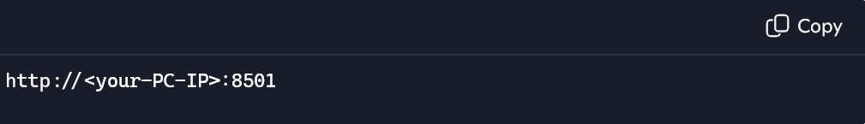
This setup provides:
- Centralized hosting
- Zero installation for team members
- Auto-start on boot
- 24/7 availability
- Easy updates
2. Prerequisites
Hardware / OS
- Windows 10 or Windows 11
- Administrator access
Software
- Python 3.10 or 3.11
- Git (optional)
- NSSM (Non-Sucking Service Manager)
- Required Python packages
Application Files
Your project folder should contain:
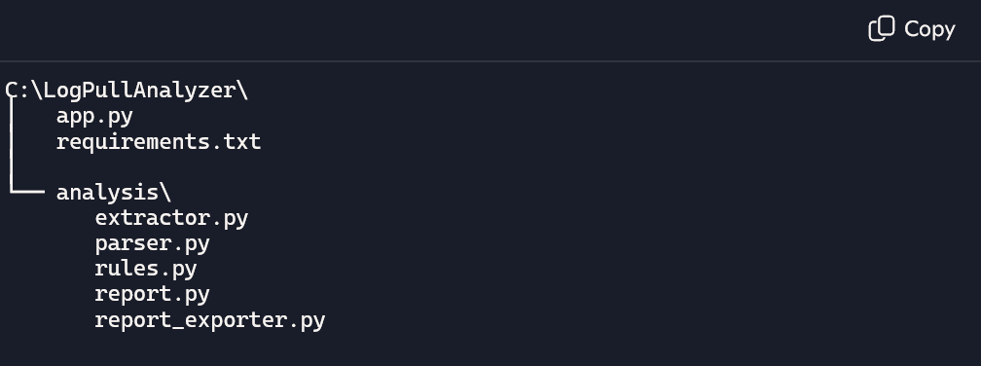

3. Install Required Software
3.1 Install Python
Download from: https://www.python.org/downloads/windows/
During installation:
- Add Python to PATH
- Install for all users
3.2 Install Python dependencies
Open PowerShell:
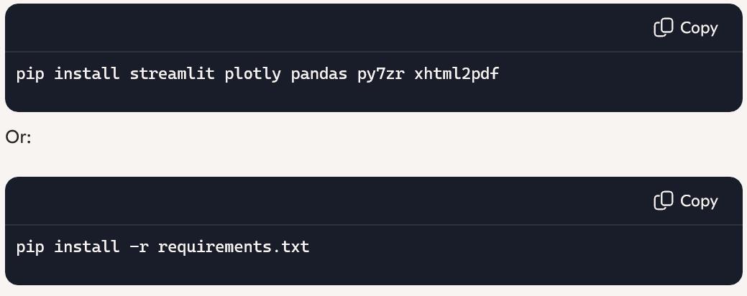4. Prepare the Application Folder
Create:
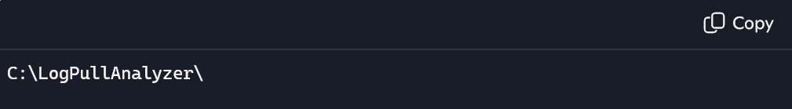
Copy all project files into this folder.
5. Test the Application Locally
Run:
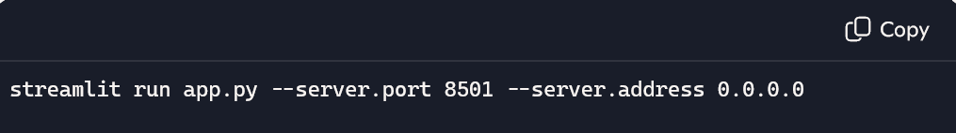
Open a browser:
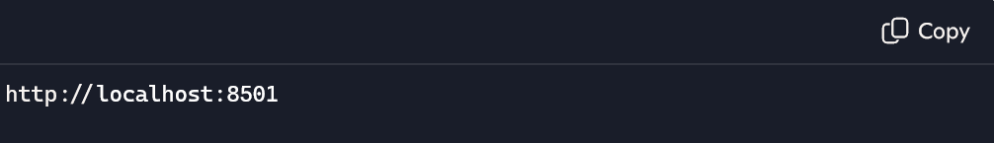
If the UI loads successfully, proceed to deployment.
6. Allow Streamlit Through Windows Firewall
Run PowerShell as Administrator:
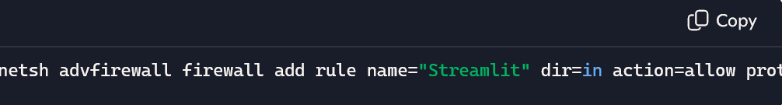
netsh advfirewall firewall add rule name="Streamlit" dir=in action=allow protocol=TCP localport=8501
This allows other devices on your network to access the tool.
7. Find Your PC’s IP Address
Run:
ipconfig
Look for:
IPv4 Address . . . . . : 192.168.x.x
Your team will use this address:
http://192.168.x.x:8501
8. Run the App as a Windows Service (Auto-Start)
We use NSSM to run Streamlit as a background service.
8.1 Download NSSM
https://nssm.cc/download
Extract to:
C:\nssm\
8.2 Create the service
Run:
C:\nssm\nssm.exe install LogPullAnalyzer
A GUI opens.
Fill in:
Application Path:
C:\Python311\python.exe
Arguments:
-m streamlit run C:\LogPullAnalyzer\app.py --server.port=8501 --server.address=0.0.0.0
Startup Directory:
C:\LogPullAnalyzer\
Click Install Service.
8.3 Start the service
nssm start LogPullAnalyzer
Your app now runs 24/7 in the background.
9. Accessing the Tool from Other Devices
Your team can now open:
http://:8501
Example:
http://192.168.1.50:8501
They do not need Python or any installation.
10. Updating the Tool
To update the tool:
- Stop the service:
nssm stop LogPullAnalyzer
- Replace files in:
C:\LogPullAnalyzer\
- Start the service:
nssm start LogPullAnalyzer
11. Optional: Create a Friendly Internal URL
If your company uses internal DNS, create:
logpull.company.local → 192.168.1.50
Then your team can use:
http://logpull.company.local:8501
12. Troubleshooting
Port 8501 not accessible
- Check firewall rule
- Ensure service is running
- Verify correct IP address
App not starting
- Check Python path
- Check NSSM logs
- Run app manually to see errors
Team cannot access
- Ensure PC is on same network
- Disable VPN temporarily
- Check corporate firewall rules
13. Deployment Complete
Your Windows PC is now a fully functional internal server hosting the Log Pull Analyzer.
Your team can use it daily without installing anything.

